Social Profile of Co. Louth

Compiled by

Social Inclusion Unit

Louth Local Authorities
(September 2004)

Contents

- Demographics Pg 4

- Unemployment Pg 7

- Persons with Low Educational Attainment Pg 13

- Persons with a Disability Pg 23

- Refugees & Asylum Seekers Pg 30

- Homeless Persons Pg 39

- Older Persons (Particularly Older Persons Living Alone) Pg 44

- One-Parent Families Pg 51

- Travelling Community Pg 59

9. Ex-prisoners Pg 67

Purpose of Social Profile
The Social Inclusion Unit has compiled this profile as part of its role in raising awareness of issues of exclusion, disadvantage and marginalisation in Co. Louth.

It is intended that this profile be used to identify areas of need in Co. Louth both socially and geographically. This may be useful in terms of making decisions and creating policy to decrease disadvantage in the county. Detailed mapping is included to illustrate patterns within the county wherever data has been available. Much of the mapping is based on data from the Small Area Population Statistics, 2002.

The information contained in the profile may also be useful as a source of information when applying for external funding (Peace II, CPA, Interreg) for projects involving particular social groups or areas in Co. Louth.

In order to establish this profile an extensive array of data was gathered and analysed. There were many problems regarding the availability of data at county level. However this was overcome by collecting and analysing information from local groups and agencies.

Demographics
(CSO, 2002)

Population

- The current population (2002) of County Louth is 101,821. This represents an increase of 10.5% since 1996 (92,166).
- The population of the county is comprised of 50,489 males and 51,332 females.
- The overall population of the county has increased, with only 5 Electoral Divisions (ED’s) experiencing a small percentage decline since 1996. In contrast the other ED’s have experienced a high percentage growth rate with nearly half increasing their population size by over 10%.

Table 1: Population changes by Age Cohort in County Louth 1996-2002
Age Group | 2002 | 1996 | % Change
0-24 | 39,484 | 38,616 | 2.2
25-44 | 30,892 | 25,744 | 20
45-64 | 20,916 | 17,853 | 17.2
65+ | 10,529 | 9,953 | 5.8
Source: CSO, 2002

Table 2: Male Population changes by Age Cohort in Co. Louth 1996-2002
Age Group | 2002 | 1996 | % Change
0-24 | 20,132 | 19,799 | 1.7
25-44 | 15,380 | 12,847 | 19.7
45-64 | 10,545 | 8,970 | 17.6
65+ | 4,432 | 4,025 | 10.1
Source: CSO, 2002

Table 3: Female Population changes by Age Cohort in Co. Louth 1996-2002
Age Group | 2002 | 1996 | % Change
0-24 | 19,352 | 18,817 | 2.8
25-44 | 15,512 | 12,897 | 20.3
45-64 | 10,371 | 8,883 | 16.8
65+ | 6,097 | 5,928 | 2.9
Source: CSO, 2002

Table 4: Population of Electoral Divisions and % Change 1996-2002
Electoral Divisions | 2002 | 1996 | % Change
Drogheda | 30,974 | 25,335 | 22.1
Dundalk | 29,187 | 27,489 | 6.2
Dundalk Rural | 14,715 | 15,138 | -2.8%
Ardee Rural | 2,500 | 2,390 | 4.6
Ardee Urban | 3,564 | 3,440 | 3.6
Castlebellingham | 1,338 | 1,391 | -3.8
Clonkeen | 438 | 402 | 9
Collon | 1,188 | 1,029 | 15.5
Dromin | 461 | 429 | 7.5
Dromiskin | 1,956 | 1,561 | 25.3
Drumcar | 1,372 | 1,404 | -2.3
Dunleer | 1,787 | 1,677 | 6.6
Stabannon | 526 | 535 | -1.7
Tallanstown | 925 | 887 | 4.3
Ballymascanlon | 2,088 | 1.927 | 8.4
Barronstown | 621 | 547 | 13.5
Carlingford | 1,334 | 1,282 | 4.1
Castlering | 847 | 745 | 13.7
Creggan Upper | 641 | 638 | 0.5
Darver | 518 | 458 | 13.1
Drummullagh | 903 | 815 | 10.8
Faughart | 843 | 872 | -3.3
Greenore | 898 | 905 | -0.8
Haggardstown | 4,894 | 4,324 | 13.2
Jenkinstown | 831 | 870 | -4.5
Killanny | 593 | 563 | 5.3
Louth | 1,196 | 1,010 | 18.4
Mansfieldstown | 454 | 424 | 7.1
Rathcor | 1,163 | 1,105 | 5.2
Ravensdale | 907 | 892 | 1.7
Clogher | 1,814 | 1,548 | 17.2
Dysart | 649 | 548 | 18.4
Monasterboice | 1,130 | 1,017 | 11.1
Mullary | 1,248 | 1,014 | 23.1
Termonfeckin | 2,033 | 1,759 | 15.6
County Louth | 101,821 | 92,166 | 10.5
Source: Gamma, 2002

Unemployment
(Source: CSO Census of Population 2002 & Live Register Analysis 2004)

Introduction
The unemployment rate (unemployment rate is defined as unemployed persons and first time job-seekers expressed as a proportion of the total labour force) in County Louth in 2002 was 13.2% of the labour force (compared with 8.6% regionally, and 8.8% nationally). The number of persons unemployed in Co. Louth has decreased by 5% since the 1996 when the unemployment rate was 18.2%. The 2002 Census of Population statistics are the only accurate statistics available on unemployment as Live Register figures merely provide a snapshot of the number of persons signing on at any one time in the county. These figures change regularly.

Significance of unemployment in terms of social exclusion and poverty

Unemployment is the largest single cause of poverty in Ireland. The unemployed are most likely to be living in poverty and least likely to obtain new jobs. The link between unemployment and poverty is particularly strong in the case of long-term unemployment and those who are excluded from the labour market. Over half the households in Ireland defined as poor in the 1997 Living in Ireland Survey were headed by someone who did not have a job. Household heads are likely to have dependents, consequently there is a high risk of poverty when the household head is long-term unemployed, when no other person in the household is in paid work and when there are a number of dependents.

Factors causing unemployment

- Low educational attainment level – difficult to obtain employment due to lack of skills
- Long-term unemployment – therefore it is difficult to return to the workforce
- Technological change – reduction in an area’s traditional industry (e.g. Dundalk – textile industry)
- Reduction in agricultural employment (particularly relevant in Co. Louth)
- History of unemployment in families/communities – many families have a long history of unemployment, it is therefore difficult for these people to return to the workforce as they are particularly accustomed to depending on social welfare and a variety of other benefits
- Economic downturn – loss of lower skilled jobs
- Rising young population – older generation of workers made redundant

Who is particularly affected by unemployment?

- Those with relatively low education and manual skills – many long-term unemployed have no formal qualifications
- The long-term unemployed (persons unemployed for 1 year or more) – the longer a person is out of work, the more difficult it is to return to the labour force
- Older long-term unemployed – chances of obtaining employment decrease as the long-term unemployed get older
- Mothers, single parents whether fathers or mothers – for whom lack childcare, and the lack of well developed family friendly employment practices is a barrier to training and work
- People with disabilities – unemployment among this group is estimated to be over 45%
- Young people (early school leavers) – with poor or no educational qualifications have a high chance of being unemployed

- Travellers – who experience both the effects of discrimination, and educational disadvantage

Job Creation & Falling Employment

Job creation and falling unemployment will not necessarily result in a drop in the number of people living in poverty. Unemployment currently prevails alongside employment growth in Ireland’s changing labour market and new jobs are likely to be filled with people who are not living in poverty than people who are.

Social Welfare Payments

The degree to which earnings are replaced by social welfare payments significantly impacts on the standard of living that people who are unemployed can maintain and therefore the extent to which they can avoid or fall into poverty. Short periods of unemployment can be supplemented by redundancy payments, family support, and savings which provide a financial cushion, however, overtime longer terms of unemployment cause these resources to be used up, and a long period out of work may result in poverty especially for a family relying on the income of the head of the household. Paid employment providing a decent wage/salary is the factor most important to raise a household out of poverty.

Numbers Unemployed in Co. Louth

The ‘unemployment rate’ is the total unemployed population, which includes those who are unemployed and first time job seekers, this figure is then expressed as a percentage of the total active labour force. A high rate is a measure of deprivation. The Labour Force Participation is the total labour force expressed as a percentage of the population aged 15 and over. A low labour force participation rate is an indicator of deprivation. Jenkinstown has the lowest labour force participation rate at 54.5%, and Tallanstown has the highest rate at 73.8%.

There were 7,010 unemployed people in County Louth in 1996. By 2002 the unemployed population numbered 6067 persons, a reduction of 13.5%. In 2002, the unemployment rate for Louth was 13.2%, marginally above the national average of 8.8%. Approximately 37% of the total unemployed population had left school with no formal education or only a primary school education (CSO, 2002). The percentage at national level was 29% and at regional level was 31%.

Table: 1 Unemployment and Labour Force Participation Rates - 2002
Electoral Divisions | % Unemployment Rate | % Labour Force Participation Rate
Drogheda | 12.8 | 61.1
Dundalk | 19.7 | 56.2
Dundalk Rural | 21.6 | 56.3
Ardee Rural | 7.5 | 58.8
Ardee Urban | 12.6 | 54.3
Castlebellingham | 12.3 | 55.7
Clonkeen | 7.4 | 67.6
Collon | 8.8 | 73.0
Dromin | 6.5 | 72.5
Dromiskin | 10.3 | 74.5
Drumcar | 9.8 | 59.2
Dunleer | 7.6 | 71.6
Stabannon | 7.8 | 81.1
Tallanstown | 6.8 | 73.8
Ballymascanlon | 8.2 | 68.3
Barronstown | 8.5 | 70.5
Carlingford | 9.8 | 67.3
Castlering | 8.9 | 58.4
Creggan Upper | 16.6 | 60.6
Darver | 9.7 | 56.8
Drummullagh | 16.9 | 53.0
Faughart | 14.0 | 54.6
Greenore | 8.0 | 58.2
Haggardstown | 8.1 | 55.8
Jenkinstown | 6.8 | 54.5
Killanny | 9.1 | 61.2
Louth | 8.5 | 61.6
Mansfieldstown | 11.2 | 58.4
Rathcor | 9.2 | 58.9
Ravensdale | 8.4 | 57.8
Clogher | 10.9 | 57.9
Dysart | 7.7 | 59.8
Monasterboice | 7.3 | 58.1
Mullary | 5.7 | 63.7
Termonfeckin | 6.3 | 57.6
County Louth | 13.2 | 58.2
Source: CSO, 2002

Main areas of Unemployment in Co. Louth

According to the 2002 Census data the Electoral Divisions in County Louth that experience the highest rates of unemployment are Dundalk Rural, Dundalk Urban, Drummullagh, Creggan Upper, Drogheda, Faughart, Castletown. Each of these ED’s contain higher unemployment rates than the county average, as well as the regional and national averages, which are lower again than the county average (Co. Louth has a relatively high unemployment rate). Out of the ED’s mentioned above the ED that experiences the lowest unemployment rate is still 4.8% higher than the national average. The ED that experiences the highest unemployment rate out of the ED’s mentioned above has a rate of unemployment 8.4% higher than the county average and 12.8% higher rate than the national average.

The ED’s that have the lowest rate of unemployment are predominantly rural areas in the middle of south of the county. Termonfeckin, which contains the lowest rate of unemployment in the county, has a rate of 6.3% which is 6.9% and lower than the county average and 2.5% lower than the national average.

Map 1: ED’s most affected by Unemployment in Co. Louth (2002)

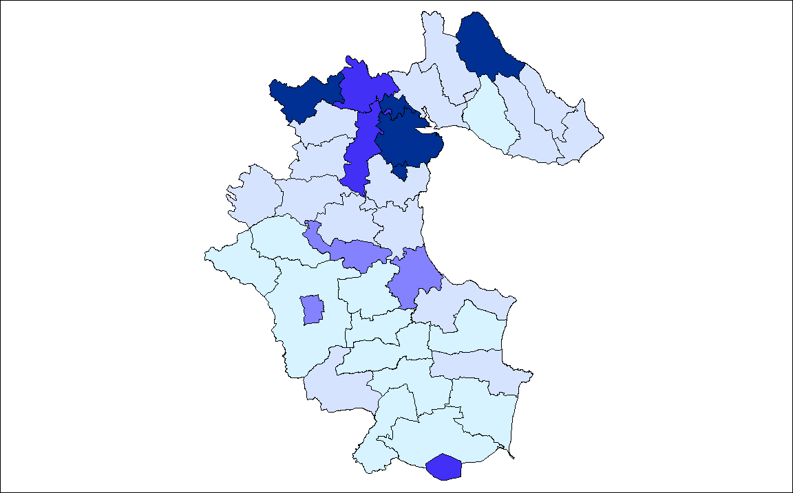

Source: CSO, 2002

Table 2 ED’s Most Affected by Unemployment in Co. Louth (2002)
ED’s most affected by unemployment | % Labour Force Unemployed
Dundalk Rural | 21.6
Dundalk U.D | 18.9
Drummullagh | 16.9
Creggan Upper | 16.6
Drogheda M.B | 14.3
Faughart | 14.0
Castletown | 13.6
Ardee Urban | 12.5
Castlebellingham | 12.3
Ardee & Environs | 12.1
Mansfieldstown | 11.2
County Average | 13.2
Regional Average | 8.6
National Average | 8.8
Live Register Statistics (CSO, Live Register Analysis May 2004)
In terms of the most recent Live Register Statistics (Department of Social & Family Affairs, May 2004), 7,330 persons were signing on in Co. Louth. This is a decrease of 144 persons from 7474 in June 2003, and a decrease of 153 persons since April 2004. 58.3% of persons signing in May 2004 were male. 11.7% of persons signing on were under 25. The number of persons signing on in Dundalk is 8.4% less than June 2003. In Drogheda the number of persons on the Live Register is 0.6% lower than June 2003. In Ardee, the number of persons on the Live Register is 0.1% higher than the previous year. In total, the number of persons on the Live Register has decreased by nearly 1.9% since June 2003.

Table 3: Live Register Statistics
 |  |  |  |  | Males |  |  | Females
 | Jun 02 | Apr 03 | May 04 | > 25 yrs | ≥25 yrs | Total | >25yrs | ≥25yrs | Total
LOUTH | 7474 | 7483 | 7330 | 860 | 3413 | 4273 | 609 | 2448 | 3057
Ardee | 905 | 918 | 906 | 123 | 366 | 489 | 82 | 335 | 417
Drogheda | 3207 | 3427 | 3343 | 345 | 1494 | 1839 | 267 | 1237 | 1504
Dundalk | 3362 | 3137 | 3081 | 392 | 1553 | 1945 | 260 | 876 | 1136
Source: CSO Live Register Analysis May 2004

NB: Please note that the Live Register is not designed to measure unemployment. It includes part-time workers (those who work up to three days a week), seasonal and casual workers entitled to Unemployment Assistance or Benefit.

Recipients of Unemployment Assistance
Persons in receipt of Unemployment Assistance are unemployed for one year or more. From these figures an approximate figure for long-term unemployment can be obtained.

Table 4: Number of Recipients of Unemployment Assistance
Area * | Number of Recipients
County Louth | 2,476
Dundalk | 1,379
Drogheda | 869
Ardee | 228
Source: DSFA, August 2004

* = Area where recipients sign for their Unemployment Assistance

Persons with Low Educational Attainment
(Source: CSO 2002)

Introduction
The central role of education in social and economic transformation is widely acknowledged. Indeed the fruits of long-term investment in education are to be seen in the unprecedented level of economic expansion and social change that has occurred in Ireland since the early 1990s.

Conversely it is widely recognised that one of the main causes of social exclusion is low educational attainment. Presently it can prove particularly difficult to secure permanent or even temporary employment, particularly white-collar employment without at least an upper secondary school education. There is a particular emphasis on the attainment of a high level of education in obtaining employment in the present job market. Those who do not hold at least a leaving certificate, third level qualification or a professional qualification are at an immediate disadvantage in terms of obtaining employment.

Education and Social Exclusion
Low educational attainment is a particularly strong indicator of social exclusion and deprivation. Low educational attainment can particularly hinder a person’s opportunity in obtaining employment. It is also difficult for persons on low income, particularly for those on social welfare benefits, to ensure their children complete second level education and obtain a third level or professional qualification. Studies have shown that families can become trapped in unemployment due to low levels of education. This is particularly true in local authority housing estates as many of local authority tenants are unemployed and dependent on social welfare benefits.

This section will outline the main areas of low educational attainment in Co. Louth and the main areas of low third level education take-up.

Level of Educational Attainment in Co. Louth
- In 2002, the percentage of persons over 15 years of age in County Louth who left school with no formal or primary education was 24.5%. The Regional Figure was 19.3% and the National Figure was 21.1%.
- 27% Males and 26% Females have Upper Secondary Education.
- The participation rate at third level for residents in County Louth was 20.6% in 2002. This compares with a 24.7% participation rate in Third level in the country as a whole for that year.

The ED’s with the highest level of population with no formal education or only primary education are mostly confined to rural areas. Drumcar contains the population with the lowest level of educational attainment in Co. Louth with 35.7% of persons in the ED with no formal education or primary education only. This is 11.2% higher than the county average and 14.6% higher than the national average. In terms of third level education attainment, Faughart, the ED with the lowest third level education attainment has a rate that is 8.8% lower than the county average and 12.5% lower than the national average.

There is also a significant correlation between ED’s (Drumcar, Tallanstown, Killanny and Clonkeen) with a high level of population with no formal or primary education, and low third level education attainment. It is interesting that the ED’s with the lowest educational attainment are mainly confined to rural ED’s. These would be the most rural ED’s in the county.

It can be noted from the figures that the national average of the population with third level education (24.7%) is higher than the county average (21%). It is also apparent that the national average of the population with no formal or primary education (21.1%) is lower than the county average (24.5%). From this it is evident that County Louth has a lower educational attainment level than the national level.

Map 1: ED’s with high % Population with No Formal Education or Primary Education
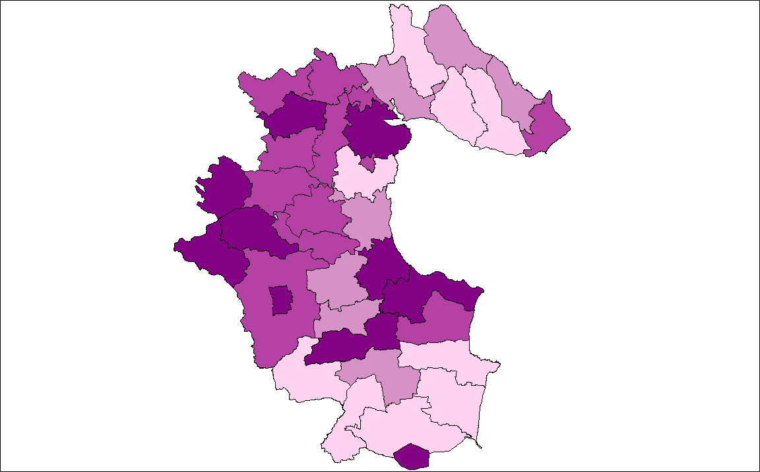
Source: CSO 2002

Table 1: ED’s with high % Population with No Formal Ed or Primary Education Only
Electoral District | % Population no formal or primary education only
Drumcar | 35.7
Tallanstown | 33.5
Killanny | 32.8
Clonkeen | 32.7
Dundalk | 30.7
Castlebellingham | 29.6
Dunleer | 29.0
Barronstown | 28.8
Ardee Urban | 28.6
Drogheda | 28.3
County Average | 24.5
Regional Average | 19.3
National Average | 21.1
Source: CSO 2002

Map 2: ED’s with low % population with Third Level Education
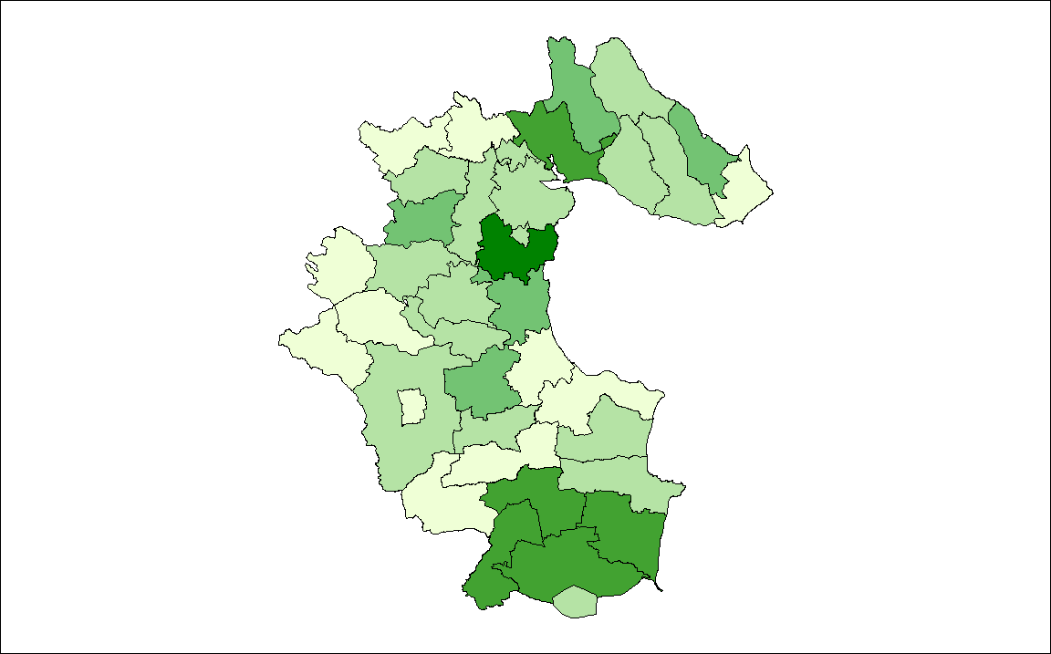
Source: CSO 2002

Table 2: ED’s with low % population with Third Level Education
Electoral District | % Population 3rd level education
Faughart | 12.2
Clonkeen | 12.7
Drumcar | 13.2
Creggan Upper | 14.0
Killanny | 15.1
Tallanstown | 15.2
Collon | 15.4
Dunleer | 15.7
Castlebellingham | 16.0
Ardee + Env | 16.0
County Average | 21.0
Regional Average | 27.0
National Average | 24.7
Source: CSO 2002

Table 3: ED’s with high % of Males with Low Educational Attainment
Electoral District | No formal or primary education only (Males)
Drumcar | 39.1
Clonkeen | 39.0
Killanny | 35.9
Tallanstown | 35.1
Barronstown | 30.4
Castlebellingham | 30.1
Dunleer | 29.2
Ardee Urban | 27.9
Ardee + Env. | 27.8
Dundalk | 27.8
County Average | 23.9
Regional Average | 19.5
National Average | 22.1
Source: CSO 2002

Table 4: ED’s with low % of Males with 3rd Level Education
Electoral District | Population third level education (Males)
Killanny | 8.7
Clonkeen | 9.1
Drumcar | 9.1
Creggan Upper | 10.6
Faughart | 11.3
Greenore | 12.1
Mansfieldstown | 12.7
Tallanstown | 13.4
Dunleer | 14.0
Drumullagh | 14.2
County Average | 19.5
Regional Average | 26.1
National Average | 23.5
Source: CSO 2002

Table 5: ED’s with high % of Females with Low Educational Attainment
Electoral District | ED’s no formal or primary education only (Females)
Dundalk | 33.6
Tallanstown | 31.8
Drogheda | 30.7
Drumcar | 30.5
Ardee Urban | 29.2
Castlebellingham | 29.1
Killanny | 28.9
Dunleer | 28.8
Ardee + Env. | 28.6
Castletown | 28.3
County Average | 25.1
Regional Average | 19.1
National Average | 20.0
Source: CSO 2002

Table 6: ED’s with low % of Females with 3rd Level Education
Electoral District | Population third level education (Females)
Faughart | 13.0
Dundalk | 15.7
Ardee Urban | 16.8
Clonkeen | 16.9
Ardee + Env. | 17.1
Tallanstown | 17.2
Castlebellingham | 17.3
Dunleer | 17.7
Creggan Upper | 18.1
Dundalk Rural | 18.1
County Average | 21.7
Regional Average | 27.2
National Average | 25.7
Source: CSO 2002

Table 7: ED’s with high levels of those Unemployed with no Formal Education – 2002
Electoral District | % Total Unemployed with no Formal Education
Killanny | 55.0
Tallanstown | 45.8
Ardee Urban | 41.1
Mansfieldstown | 40.0
Drumcar | 38.0
Dundalk Rural | 36.0
Castlering | 35.7
Louth | 35.7
Creggan Upper | 35.1
Faughart | 34.3
County Louth | 30.6
Source: CSO 2002

Table 8: ED’s with high levels of those Unemployed with 3rd Level Education
Electoral District | Total Unemployed with 3rd Level Education
Dromin | 27.3
Ballymascanlon | 22.1
Haggardstown | 21.8
Creggan Upper | 21.6
Ravensdale | 19.4
Dysart | 19.0
Carlingford | 14.9
Monasterboice | 14.8
Termonfeckin | 14.0
Clogher | 13.7
County Louth | 12.5
Source: CSO 2002

Education, Training and Lifelong Learning

Educational Facilities in County Louth
There are 81 primary and 17 post-primary schools in County Louth.

Table 9: Schools in Co. Louth (Primary Schools)
County | Ordinary | Special | Total
Louth | 78 | 3 | 81
Source: Department of Education & Science, July 2004

Table 10: Post - Primary Schools in Co. Louth
County | Secondary | Vocational | Community | Comprehensive | Total
Louth | 11 | 5 | 1 | - | 17
Source: Department of Education & Science, July 2004

Graph 1: Post-Primary Schools in Co. Louth
Source: Department of Education & Science, July 2004

Educational Disadvantage
In Co. Louth there are 15 Home School Liaison Officers as of August 2004, there are 7 Officers who deal with pupils in Post Primary Schools and 8 who work with pupils in Primary Schools. There are 13 schools in receipt of the School Completion Programme and there are 4 Educational Psychologists located within the County. There are also 36 Learning Support Teachers.

Educational Services to People with an Educational Disadvantage

Adult Literacy Service
One of the main aims in 2001 for the adult literary service was to heighten public awareness of the services available at local level. Also during the year 2001, Adult Literacy Organisers and the Adult Literacy Organiser of Louth developed networks between local voluntary groups, statutory bodies, and Resource Centre managers.

Vocational Training Opportunities Scheme (VTOS)
The Vocational Training Opportunities Scheme is an umbrella title used by the Department of Education and Science to describe specific full time educational/training courses aimed at those on the Live Register, and those in essence most marginalised.

Return to Study
County Louth V.E.C. was among the first to offer a Return to Study course in the country. The courses afford adults the opportunity, at no financial cost to themselves, to enter and participate in a variety of subject areas and in so doing to identify areas of interest. The Return to Study Courses were offered in May-July 2000 for an 8-10 week duration in two venues, Dundalk and Drogheda, based in the Adult Education Centres located in each town.
Tara Travellers Workshop
Since the official change over from FÁS to County Louth V.E.C. the Tara Travellers Education Centre has made changes to the level and quality of services on offer to its client group. Personal development and Job seeking skills form an integral part of the curriculum. This workshop focuses on Personal Development and Social Skills as well as providing classes in Literacy and Maths. Cognisant of the culture of travellers and their own innate skills base, the VEC aim to introduce to the students new skills such as Glass Craft, Sculpture, Copper Craft and Art/Design to build upon existing skills base.

Home School Liaison Officers
The Home School Liaison Officers are drawn from an educational/teaching background. The role of such personnel is to liaise with parents of school going children to encourage parental involvement in their own child’s learning. They also liaise with teaching personnel in the school to foster a greater understanding of the benefits and need for parental involvement in school activities by organising developmental courses for parents in the school catchment areas.

YouthReach
The Department of Education and Science have established and enhanced new and existing educational opportunities for this client grouping. These programmes include YouthReach, and special out of school community based initiatives. The aim of YouthReach is to provide participants with the knowledge, skills and attitudes required to successfully make the transition to work and adult life, and to participate fully in their communities. YouthReach is aimed at young unemployed people who are generally at least 6 months in the labour market, aged 15-18 who have left school without any qualifications.

The Department of Education and Science, under the YouthReach programme, have allocated 85 places between the two centres in Dundalk and Drogheda. The YouthReach initiatives in Co. Louth operate in the Second Chance Education Project, The House, Cox’s Demesne, Dundalk and the Dundalk YouthReach, Chapel Street. In Drogheda it is located on King Street, Drogheda. The allowance made payable to trainees aged 18 or above is €110 per week. To trainees aged 17 or below it is €55 per week. The type of training provided in YouthReach includes Woodwork, Maths, Commerce, Needlecraft, Childcare, Catering, Metalwork, Sport, Personal/inter-personal skills, Computer literature and Computer Graphics.

School Completion Programme
The main programme within the Department for tackling the issue of early school leaving is the School Completion Programme, which was launched in 2002. The School Completion Programme incorporates the learning, experience and best practice derived from previous early school leaving initiatives and assimilates the 8 to 15 Early School Leaver Initiative (ESLI) and the Stay-in-School Retention Initiative at Second Level (SSRI).

The Programme is based on an integrated cross-community approach to tackling educational disadvantage, involving primary and post primary schools, parents, communities and relevant
statutory and voluntary agencies. Its objective is to provide a range of interventions in areas of disadvantage that support the retention of young people in education. Eligible schools were selected on the basis of their pupil retention rates from the Department's Post-Primary Pupil database.

Schools are grouped into 82 clusters of one or more second-level schools and their main feeder primary schools. Each cluster has established a committee composed of principals, voluntary and statutory agencies including County Development Boards, Local Drug Task Forces, Area Partnerships, the local programme coordinator, parents, community interests etc. This committee is responsible for developing and overseeing implementation of a fully costed, integrated plan to tackle early school leaving in the area, including specific retention targets. At
present, 405 schools have been included in the School Completion Programme (295 primary and 110 post primary), which is supported by a national coordinator and four assistant coordinators.

There are 3 School Completion Clusters in County Louth, encompassing 3 post primary and 10 primary schools. A School Completion Programme coordinator has been appointed to work with each of these clusters. In 2004, the three clusters received a combined allocation of €646,000. This represents a significant resource for tackling early school leaving in County Louth.

Disadvantaged Areas Scheme
This Scheme benefits schools by providing additional capitation grants of €38 per capita, a maximum class size of 29:1, a refund of the Television Licence fee and eligibility for 95% building grants for building projects. There are 311 primary and 203 post primary schools across the country with designated disadvantage status. There are 7 Post Primary and 9 Primary schools in the Disadvantaged Areas Scheme in county Louth.

Home School Community Liaison Scheme (HSCL)
The HSCL scheme is concerned with establishing partnership and collaboration between parents and teachers in the interests of the child’s learning. The HSCL Scheme also operates transfer programmes to help primary school pupils to make the transition to post primary level. A HSCL coordinator works with school staff, parents and relevant community agencies in advancing these aims. A National Co-ordinator and two assistant co-ordinators oversee the day-to-day operation of the Scheme.

All 311 primary and 203 post primary schools with designated disadvantaged status were invited to join this scheme in 1999. There are seven Post Primary and eight Primary schools in Louth in the Home School Community Liaison Scheme.

National Educational Psychological Service
There are four educational psychologists serving schools in County Louth.

Special Needs Education
Children with literacy or numeracy problems are catered for by the Learning Support Teacher Service. The Resource Teaching scheme operates in schools catering for pupils with more severe learning difficulties and disabilities.

There are 36 learning support teachers and 67 resource teachers currently assigned to schools in County Louth to cater for pupils with learning difficulties and special educational needs.

Persons with a Disability
(Source: DSFA May 2003)

Disability: A Definition
A person with a disability is: “A person who has a physical disability, sensorial impairment, learning difficulty or mental illness who, as a result, cannot function at what is considered normal level” (Combat Poverty Agency).

Inaccessibility = Exclusion?

Lack of an adequate income compounds the social exclusion experienced by people with disabilities. The built environment is largely inaccessible to many people with disabilities and denies them mobility, participation and opportunity. This makes:
- Public transport inaccessible
- Restaurants, cinemas and other social outlets difficult or impossible to visit
- Educational, training and work opportunities difficult or impossible to access

Disability: A Multi-Faceted Issue

Poverty and social exclusion experienced by people with disabilities will not be solved simply by increasing or reforming welfare payments. Poverty results from a wider institutional discrimination against disabled people and tackling it involves taking a rights based approach to disability.

The Extra Costs of Disability

Adequate income is a necessity in modern society and lack of such an income is a major cause of exclusion, isolation and poverty. Allowances paid to people with disabilities are low and do not reflect disability related costs, which differ according to type and severity of disability. In addition some disability-related costs are incurred whether or not people with disabilities are earning an income. Means-testing as a basis for allocating allowances overlooks this and acts as a disincentive to people with disabilities who want to take up employment.

Disability in County Louth

In terms of the number of persons with some sort of a disability in County Louth, in May 2004, there are a total of 6,331 persons in receipt of some form of disability payment from the Department of Social & Family Affairs. However, there are undoubtedly more persons in the county with some sort of a disability, as the United Nations state that at any one time approximately 10% of any given population have a disability of some sort. Persons in receipt of disability payments from the Department of Social & Family Affairs are in the main unemployed or on low incomes, and therefore more susceptible to financial poverty and social exclusion than the rest of the population. In County Louth, the main age groups in receipt of disability benefits are the 55-65, 45-54, 35-44 groups. There are also 265 more females than males in receipt of disability payments in Co. Louth.

Social Welfare Disability Benefits (inc. no. of persons in receipt of these benefits in Co. Louth)
- Invalidity Pension is a payment made to people who are permanently incapable of work because of an illness or incapacity (2287 persons May 2004)
- Disability Benefit is a payment made to insured people who are unable to work due to illness (2375 persons May 2004)
- Disability Allowance is a weekly allowance paid to people with a disability who are aged 16 or over and under age 66. Your disability must be expected to last for at least one year and the allowance is subject to both a medical suitability and a means test (1169 persons May 2004)
- Blind Person's Pension is a pension paid to blind people and certain people with low vision, aged 18 or over who are normally living in the State and satisfy a means test (61 persons May 2004)
- Disablement Pension can be paid to you, if as a result of an accident at work or a prescribed disease contracted at work, you suffer a loss of physical or mental faculty (482 persons Dec 2003)

Table 1: No. of Persons on Particular Disability Benefits by Age Group in Co. Louth
Age Group | Invalidity pension | Disability Benefit | Disability Allowance | Total
<25 | 0 | 67 | 287 | 354
25-34 | 29 | 447 | 351 | 827
35-44 | 157 | 626 | 318 | 1101
45-54 | 558 | 625 | 321 | 1504
55-64 | 1199 | 590 | 357 | 2146
65+ | 344 | 20 | 35 | 399
Total | 2287 | 2375 | 1669 | 6331
Source: DSFA, May 2004

Graph 1: No. of Persons on Particular Disability Benefits by Age Group in Co. Louth

Table 2: No. of Persons on Particular Disability Benefits by Gender in Co. Louth
Gender | Invalidity pension | Disability Benefit | Disability Allowance | Total
Males | 1142 | 836 | 1055 | 3033
Females | 1145 | 1539 | 614 | 3298
Total | 2287 | 2375 | 1669 | 6331

Source: DSFA, May 2004

Graph 2: No. of Persons by on Particular Disability Benefits by Gender in Co. Louth
0
200
400
600
800
1000
1200
1400
1600
1800
Invalidity Pension
Disability Benefit
Disability
Allowance
Males
Females

Table 3: Disability benefit clients in Louth by incapacity
Top 25 Incapacities | Total
Back/Neck/Rib/Disc | 350
Anxiety/Depression | 316
Other Incapacity | 191
Arthritis/Rheumatic/Old Age | 108
Pregnancy Problems | 98
Stress | 88
Post Operation/Surgery Debility | 85
Nerve Debility/Bereavement | 82
Hypertension | 72
Limb Injury | 60
Fracture/Break | 58
Post Natal Depression/Paranoia | 57
Abdominal/Gastric | 47
Bypass/Cardiac | 45
Anaemia | 42
Leg/Knee/Ankle Injury | 38
Investigations | 37
Vertigo | 34
Acute Repertory Infection | 32
Shoulder/Elbow/Arm Injury | 32
Multiple Injury | 31
Asthma | 30
Sciatica | 20
Baldder/Kidney | 18
Epilepsy | 17
All other Incapacities | 387
Total | 2375
Source: DSFA, May 2004

Table 4: Total No. of Persons on Particular Disability Benefits (inc. Blind Persons Benefit and Disablement Pension) in Co. Louth
Invalidity pension | Disability Benefit | Disability Allowance | Blind person's pension | Disablement pension | Total
2287 | 2375 | 1169 | 61 | 482 | 6374
Source: DSFA, May 2004

Graph 3: Proportion of Persons on Particular Disability Benefits (inc. Blind Persons Benefit and Disablement Pension) in County Louth
2413
1515
62
2148
482
Invalidity Pension
Disability Benefit
Disability Allowance
Blind Person's Pension
Disablement Pension
Source: DSFA, May 2004

Table 5: % Age Profile of People with a Disability in County Louth
% Persons with a Disability Aged 1-14 | % Persons with a Disability Aged 15-24 | % Persons with a Disability Aged 25-44 | % Persons with a Disability Aged 45-64 | Persons with a Disability Aged 65 +
5.1 | 5.9 | 19.7 | 30.0 | 39.3
Source: CSO 2002

From Table 5 it is clear that the greatest percentage of people with a disability is in the 65+ age group.

Persons with an Intellectual Disability
In August 2004 there were a total of 862 clients on the NEHB Intellectual Disability Database in Co. Louth. Louth Disability Services provide a range of day and residential services to people with learning disabilities. These are delivered by both the NEHB and the voluntary sector based in St. John of God’s, Drumcar.

Persons with a Visual Disability
172 persons in County Louth are registered as being blind with the Blind Council (July 2004). However, there could be twice as many persons with a visual impairment in the county as many are not registered for various reasons. It should also be noted that the majority of the 172 persons registered with the Blind Council are not in receipt of Blind Persons Pension as they do not satisfy the means test.

Disabled Persons and Local Authorities
Disabled Persons Grant
Under this scheme, a Local Authority may make a grant for the provision of additional accommodation or necessary works of adaptation to your house to meet the needs of a member of the household who is disabled. There is no income limit for eligibility. The grant may be up to 90% of the approved cost of the works in the case of private houses and up to the full cost of the works in the case of houses let by the Local Authority, to a maximum grant of €20,320.

National Policy and Persons with a Disability

Part M of the Building Regulations
Part M of the Building Regulations requires that access for people with disabilities to public buildings (hotels, restaurants, cinemas etc.) must be provided. Primary responsibility for compliance with the regulations rests with the designers, builders and owners of buildings.

Barcelona Declaration Project
The Barcelona Declaration is a European wide project that aims to create an inclusive society. It contains specific goals, which relate to all aspects of our lives, including social, environmental and economic issues.

Aims of Barcelona Declaration Project
- To encourage local government to make provision for the inclusion of people with disabilities in the community, which it represents.
- To provide an opportunity for elected representatives and staff members of local authorities to work in consultation with local disability advocates.
- In many aspects of housing, transportation, access to public buildings and information, our cities, towns and villages fail to meet the needs of all those who live there. Elderly people and people with disabilities should be enabled to live independently in the community.

The seventeen agreements of the project can be summarised as follows:
- Promote disability awareness in the workplace and the community
- Develop policies and equality/disability proof decision-making processes
- Develop consultative processes
- Provide people with disabilities access to the social and physical environments as well as services
- Provide training programmes dealing with equality/disability issues
- Develop monitoring, evaluation and impact assessment procedures for actions, projects and policies regarding equality/disability issues.

Recent developments related to the Barcelona Declaration Project in Louth Local Authorities
- Publication of “information booklet” on disability awareness for staff & elected members
- Provision of training for staff & elected members on disability awareness
- Purchase & display of banner promoting EU Year for People with Disabilities – displayed on County Hall, Dundalk Town Hall, and in Drogheda
- Identification of disability actions in 2004 Operational Plans
- Establishment of BDP Implementation Team focusing on disability actions identified in 2004 Operational Plans

National Disability Authority
The National Disability Authority (NDA) is an independent agency established under the aegis of the Department of Justice, Equality and Law Reform. The NDA provides a key focal point for disability in the mainstream.
- To act as a central, national body to assist in the co-ordination and development of disability policy
- To undertake research and develop statistical information for the planning, delivery and monitoring of disability programmes and services
- To monitor the implementation of standards and codes of practice in programmes and services for people with disabilities
- To liaise with service-providers and other bodies to support the development and the implementation of appropriate standards for programmes and services for people with disabilities.
- The statutory remit of the NDA is set out in the National Disability Authority Act, 1999.

Please see “Disability – An Information Booklet”, compiled by the Social Inclusion Unit, Louth Local Authorities, 2003

Refugees & Asylum Seekers
(Source: North Eastern Health Board, April 2004)

Definitions of Refugees & Asylum Seekers
The Refugee Act 1996 commenced in full in the year 2000. It has become the national framework for the legal status of all asylum seekers and refugees entering Ireland.

An Asylum Seeker is defined as:
“A person who seeks to be recognised as a refugee in accordance with the terms of the 1951 Geneva Convention relating to the Status of refugees and the related 1967 protocol”

In Ireland, this means that a person who arrives in the state seeking asylum or seeking the protection of the state against persecution or requesting not to be returned or removed to a particular country, or otherwise indicating an unwillingness to leave the state for fear of persecution.

Refugees
Refugees are classified as either convention refugees or programme refugees.

Convention Refugees
A Convention Refugee according to the Refugee Act, 1996 is a person who;
“Owing to a well founded fear of being persecuted for reasons of race, religion, nationality or membership of a particular social group or political opinion is outside the country of his or her former habitual residence, is unable, or owing to fear is unwilling to return to it”.

Programme Refugees
A Programme Refugee, as distinct from a convention refugee, is a person:
“ To whom leave to enter and remain in the state for temporary protection or resettlement as part of a group of persons has been given by the Government and whose name is entered in a register established and maintained by the Minister for Foreign Affairs”.

Programme Refugees are persons who are invited to Ireland by the Government usually in response to a humanitarian crisis and at the request of the UNHCR. Refugees are entitled to seek and enter employment, to carry out a business, trade or profession and access education and training. They are also entitled to receipt of social welfare benefits, medical care and services in line with Irish citizens’ entitlements. Accordingly, refugees are entitled to reside in the state, to travel in and out of the state, access the courts, form and be a member of an association or trade union and have the freedom to practice religion.

Unfortunately there are no figures available from the Department of Justice, Equality & Law Reform for refugees at county/local level. These figures remain confidential for the security of the refugee.

Refugees/Asylum Seekers and Social Exclusion
Refugees and Asylum Seekers in particular in Ireland are susceptible to high levels of poverty, social exclusion, and disadvantage. This is due to:

- Reliance on government payments and accommodation provision in the case of asylum seekers (only asylum seekers who have entered and lived in the state for at least one year on or before July 1999 are permitted to take up paid employment)
- In many cases (depending on the particular ethnic group), low educational attainment levels, high levels of illiteracy, and lack of ability to communicate in English
- Lack of ability to access many goods and services due to inability to communicate in English, and due to lack of income
- General poor health status, again due to lack of ability to access services, mistrust of health authorities, and the change in surrounding environment
- Direct and indirect discrimination due to their culture, appearance, perception of lifestyle, and way of life (children face discrimination at school in particular)
- Many asylum seekers experience severe social exclusion and hardship due to direct provision accommodation. They are confined into one place, they have little or no money, little or no communication with the outside world, and have no independence.

Asylum Seekers and the North Eastern Health Board Region
Information provided by the North Eastern Health Board indicates that in County Louth 380 applications for asylum were made in April 2004, 126 of whom had a spouse. There are 352 child dependants in total. This gives a total of 858 asylum seekers in County Louth as of the 30th of April 2004.

The countries of origin with the highest percentage of applicants up to the 30th of April 2004 in the North Eastern Health Board area were:
- Nigeria – 65.9%
- Romania – 6.2%
Other applicant countries of origin include: Belgium (0.3%), Croatia (0.7%), Czech Republic (0.3%), Ghana (1.6%), Congo (2.3%), Angola (0.8%), Zimbabwe (0.7%), Lithuania (1.5%), Israel (0.7%), Russia (1%), Poland (0.7%), Ukraine (1.1%), Albania (0.5%), Somalia (1.1%), Kenya (2.2%), Moldova (0.7%), South Africa (0.8%), Palestine (0.1%), Azerbaijan (0.1%), Hungary (0.1%), Bulgaria (0.3%), Kosovo (0.1%), Libya (0.3%), Egypt (0.1%), El Salvador (0.1%), Mali (0.1%), Estonia (0.3%), Gambia (0.1%), Sierra Leone (0.3%), Georgia (0.2%), Ivory Coast (0.5%), Togo (0.3%), Benin (0.1%), Cameroon (1%), Gabon (0.1%), Rhwanda (0.1%), Uganda (0.2%), Zambia (0.3%), Malawi (0.1%), Swaziland (0.1%), Kazakhstan (0.1%), Latvia (0.1%), Liberia (0.1%), Cuba (0.1%), Jamaica (0.2%), Brazil (0.1%), Syria (0.1%), Iraq (0.2%), Pakistan (0.2%), Bangladesh (0.1%), Maldives (0.1%), Slovakia (0.1%), China (0.2%), Sudan (0.2%), Ukraine (1.1%), Uzbekistan (0.2%), Unknown (0.1%), Other (2.7%).
N.B. The above figures do not include Adult or Child Dependants

In the NEHB region the total number of asylum seekers as of the 30th of April 2004 is 1815. Over 47% of all asylum seekers in the NEHB region are based in County Louth. Within the region the NEHB accommodates 845 asylum seekers in Direct Provision, and 970 asylum seekers in Non-direct provision. Other Direct Provision locations include Mosney in County Meath with 700, St. Laurence’s Lodge in Drogheda, County Louth with a capacity of 90, Kinora House in Dundalk, County Louth with 50 and St. Patrick’s in County Monaghan with 150.

Graph 1: Asylum Seekers’ Country of Origin
Country of Origin
Belgium
Croatia
Other
Palestine
Azerbaijan
Poland
Hungary
Romania
Bulgaria
Albania
Kosovo
Czech Republic
Libya
Egypt
El Salvador
Mali
Estonia
Nigeria
Gambia
Sierra Leone
Georgia
Ivory Coast
Ghana
Togo
Benin
Nigeria
Cameroon
Gabon
Congo
Rhwanda
Angola
Somalia
Kenya
Uganda
Zambia
Zimbabwe
Malawi
Swaziland
Kazakhstan
Latvia
Liberia
Lituania
Cuba
Jamaica
Moldova
Brazil
Syria
Iraq
Israel
Russia
Pakistan
Bangladesh
Maldives
Slovakia
Philippines
South Africa
China
Sudan
Ukraine
Uzbekistan
Unknown

Table 1: Location of Applicants in the NEHB Region
 | Claimants | Spouse | Dependants  (under 18) | Total
Region | 867 | 246 | 702 | 1815
Cavan/Monaghan | 78 | 29 | 71 | 178
Louth | 380 | 126 | 352 | 858
Meath | 409 | 91 | 279 | 779
Region (Non Direct Provision) | 538 | 138 | 294 | 970
Region *  (Direct Provision) | 329 | 108 | 408 | 845
Source: NEHB, July 2003

Graph 2: Number of Asylum Seekers by County in NEHB Region
1815
178
858
779
0
200
400
600
800
1000
1200
1400
1600
1800
2000
1
Region
Cavan/Monaghan
Louth
Meath

Graph 3: Percentage of Asylum Seekers by Accommodation Type
Accommodation of Asylum Seekers in NEHB area
53%
47%
Non-direct provision
Direct provision

A breakdown of applicants dispersed throughout the NEHB region is displayed in the following table. Of the 858 dispersed by the NEHB into County Louth, the majority of asylum seeker applicants were placed in Dundalk (254) followed by 124 placed in Drogheda.

NB: It should be noted in relation to Drogheda that there are 322 claimants (not including adult and child dependants) in the Mosney Direct Provision Centre in Co. Meath. Most of these people would avail of services in Drogheda as it is the nearest major town.

Table 2: Location of Applicants in Co. Louth
Area | Number of Asylum Seekers
Ardee | 1
Dunleer | 1
Drogheda | 124
Dundalk | 254
Entire Total 380 | 126 Adult Dependants 352 Child Dependants
Source: NEHB, July 2004

Graph 4: Location of Asylum Claimants in Co. Louth
Locations of Claimants in Co. Louth
66%
32%
1%
1%
Dundalk
Drogheda
Ardee
Dunleer
Source: NEHB, July 2004

Number of Asylum Seekers in County Louth since June 2001
The following table and graph highlight that the population of asylum seekers in Co. Louth showed a large increase from June 2001 to August 2002, and then decreased in September 2002. The population rose to 1,270 in April 2003 and since then has subsequently decreased each month. The most recent figure received from the NEHB for June 2004 suggests that there are 834 asylum seekers in County Louth.

Table 3: Number of asylum seekers in County Louth since June 2001
Month / Year | No. of Asylum Seekers | Month / Year | No. of Asylum Seekers
June 2001 | 1,080 | August 2003 | 1,109
January 2002 | 1,222 | September 2003 | 1,057
June 2002 | 1,303 | October 2003 | 992
August 2002 | 1,405 | November 2003 | 974
September 2002 | 1,171 | December 2003 | 986
November 2002 | 1,229 | January 2004 | 967
December 2002 | 1,205 | February 2004 | 934
January 2003 | 1,226 | March 2004 | 903
March 2003 | 1,218 | April 2004 | 858
April 2003 | 1,270 | May 2004 | 848
June 2003 | 1,194 | June 2004 | 834
July 2003 | 1,177
Source: NEHB, July 2004

Graph 5: Number of asylum seekers in County Louth since June 2001
Source: NEHB, July 2004
Refugee Act, 1996
The principal aim of the Refugee Act, 1996 (as amended) is to give statutory effect to the State's obligations under the 1951 Geneva Convention Relating to the Status of Refugees and the related 1967 Protocol.

Refugee Applications Commissioner, & the Refugee Appeals Tribunal
Under the Refugee Act, 1996 your application for a declaration as a refugee will be dealt with:
- At first instance by the Refugee Applications Commissioner,
- At appeal (if one is made) by the Refugee Appeals Tribunal,
- And finally, based on the recommendation of the Refugee Applications Commissioner or the Refugee Appeals Tribunal, a decision will be taken by the Minister.
Making an Application for a Declaration as a Refugee
At the Office of the Refugee Applications Commissioner or at the Port of Entry
- Complete an application form for a declaration as a refugee.
- Application must be accompanied by any original travel documents (passport) in your possession and, if appropriate, those of your children aged <18 years.
- Initial interview, in order to establish wish to make an application for a declaration, and if so:
  - The general grounds upon which the application is based;
your identity, nationality and country of origin;
  - The method of your entry to the State
  - The reason why you are in the State;
  - The legal basis for your presence in the State;
  - Any other basic information, which the Refugee Applications Commissioner requires.
- End of your interview be advised of right to consult a solicitor and the UNHCR.
- Photograph taken.
- Completion of questionnaire and returned at specified date.
- Return of questionnaire and issue of Temporary Residence Certificate.
- Referral to the Directorate of Asylum Support Services and arrangements made to be taken to Reception Centre in the Dublin area.
- Relocation to accommodation, which may be outside the Dublin area. This is where the asylum seeker will be expected to remain while their application for declaration as a refugee is being processed

Rights of Asylum Seekers

Residing in Direct Provision Accommodation
- Weekly basic payment under Supplementary Welfare Scheme of €19.10 in respect of asylum claimant, €19.10 in respect of dependent/spouse/partner, and €9.55 in respect of each residing child dependent

Residing in Private Rented Accommodation
Since April 2003 Asylum Seekers are required to serve their time in direct provision they are therefore no longer able to reside in private rented accommodation. However for those who were part of the programme before April 2003 are still entitled to:
- Weekly basic payment under Supplementary Welfare Scheme of €134.80 in respect of claimant, €89.40 in respect of dependent/spouse/partner, and €16.80 in respect of each child dependent
Asylum Seeker/Refugee Support Groups in County Louth
Co. Louth based Asylum Seeker/Refugee support groups include:
- One World Spirit
- Louth African Support
- Dundalk Roma Support Group
- Drogheda Immigrant Group

Table 4: Other relevant organisations in relation to application for refugee status
Refugee Legal Service,  79/83 Lower Mount Street,  Dublin 2  Freephone: 1800 229 222  Tel: 01 6310800 | Irish Refugee Council,  40 Lower Dominick Street,  Dublin 1  Tel: 8730042 | Irish Refugee Council,  1 Bank Place,  Ennis,  Co. Clare  Tel: 065 6822026
Irish Red Cross Society,  16 Merrion Square,  Dublin 2  Tel: 01 6765135 | Amnesty International,  48 Fleet Street,  Dublin 2  Tel: 01 6776361 | Eastern Regional Health Authority,  Refugee Unit,  79/83 Lower Mount Street,  Dublin 2  Tel: 01 6028000

Please see “Refugees & Asylum Seekers – An Information Booklet”, compiled by the Social Inclusion Unit, Louth Local Authorities, 2003

Homelessness
(Source: Dundalk Simon Community, Drogheda Homeless Aid Association, Louth Local Authorities, North Eastern Health Board, 2004)

Defining Homelessness

According to the 1988 Housing Act a person shall be regarded by the housing authority as being homeless if:
- There is no accommodation available which, in the opinion of the authority, s/he, together with any other person who normally resides with her/him or who would reasonably be expected to reside with her/him, can reasonably occupy or remain in occupation
- S/he is living in a hospital, county home, night shelter or other such institution, and is so living because s/he has no accommodation of the kind referred to in paragraph A, and s/he is in the opinion of the authority, unable to provide accommodation from his own resources

Why do People Become Homeless?

- Mental illness: 50% of persons in homeless hostels have severe mental health problems.
- Addiction problems (30%): on average, 20% of homeless persons misuse drugs and 40% suffer from alcohol dependence. There is no estimation available for those who are addicted to gambling
- Other reasons (20%):
  - Poverty: Financial destitution
  - Housing shortages: lack of affordable accommodation and regulation of the housing market
  - Relationship breakdown: irreconcilable personal differences, family violence, sexual abuse, rejection, or parents who are unable to care
  - Institutionalisation: experience of the care system or prison can lead to homelessness

Number of Homeless Persons in County Louth

The table below outlines the number of homeless persons in Louth as of June 2004. Due to the transient nature of homeless persons, these figures are approximations.

Table 1: Number of homeless people in Co. Louth, June 2004
Area | Number of homeless persons
Dundalk | 31
Drogheda | 23
Rural Louth | 0
County Louth Total | 54
Source: Dundalk Simon Community, Drogheda Homeless Aid, Louth Local Authorities, NEHB (June 2004)

Graph 1: Proportion of Homeless People in Co. Louth by Area, June 2004

Accommodation Options for Homeless Persons in County Louth

Homeless applicants (must be over 18 years of age) to Louth Local Authorities are accommodated in one of three ways:
- Hostel accommodation
  - Two refuges for women and their children fleeing domestic violence (Dundalk & Drogheda)
  - Two hostels for single men (Dundalk & Drogheda)
- Bed and breakfast accommodation – each housing authority maintains a list of privately owned Bed and Breakfast guesthouses, which will accept homeless referrals. This accommodation is provided on a very short-term basis, generally for 3 nights. The local authority pays for the first week, after that the onus for payment is on the homeless person.
- Private rented accommodation

Services to the Homeless Persons in County Louth

Drogheda Homeless Aid Association – St. Joseph’s Hostel

Drogheda Homeless Aid Association was established in 1984 to address the needs of homeless men in the Drogheda area. St. Joseph’s Hostel caters for 22 residents at any one time. During the day St. Joseph’s Hostel would provide meals for 15 homeless men. Since 1982 Drogheda Homeless Aid has helped over 1,500 men. On average 84 homeless men will benefit each year by living in St. Joseph’s Hostel.

Drogheda Women’s Refuge and Children’s Centre

Drogheda Women’s Refuge and Children’s Centre was opened in 1998 and offers safe accommodation to women and children fleeing violence in their own homes. The centre provides a broad range of services including child and adult counselling, a 24 hour helpline, an accompanying service, a child care centre, a weekly support group, advocacy, a transition programme and education programmes, which all aim to break the cyclical pattern of violence, abuse and neglect. The Centre can accommodate up to four families at any one time which comprises of four women and twelve children. Since opening in 1998 the service has accommodated approximately 297 women and 414 children. From June 2003 to June 2004 the centre dealt with 47 women and 64 children. During this period the centre received 608 distressed calls on their helpline.

Dundalk Simon Community

The Simon Community in Dundalk is affiliated to a national federation consisting of the four Simon Communities in the Republic of Ireland, Dublin, Cork, Galway and Dundalk. The Simon Community House in Dundalk acts as both an emergency shelter and residential house for up to twenty five homeless persons. At present (July 2004) the Simon Community accommodates eleven persons who have been resident there for a year or more. Settlement is a process in the Simon Community which helps homeless persons to move from the Simon house to alternative accommodation. On the 14th of June 2004 the Simon Community set up The Gate House Project. This is a rough sleeper’s shelter and consists of seven beds. This project will only accommodate seven people at any one time.

Table 2: Number of Homeless Persons in Co. Louth
Month | Total
June 2003 | 31
July 2003 | 30
August 2003 | 33
September 2003 | 28
October 2003 | 32
November 2003 | 34
December 2003 | 30
January 2004 | 30
February 2004 | 35
March 2004 | 33
April 2004 | 30
May 2004 | 31
June 2004 | 31
Total | 408
Source: Dundalk Simon Community, July 2004

Dundalk Women’s Aid

Dundalk Women’s Aid seeks to work towards the elimination of violence against women and their children in their home. The aims of Dundalk Women’s Aid are:

(a) To provide safe, secure and acceptable accommodation for women and their children who are victims of domestic violence;

(b) To provide an ongoing support network to these women and children.

Dundalk Women’s Aid normally caters for five families at any one time but in special circumstances can cater for double.

Local / National Policy on Homelessness

Government's Integrated Strategy on Homelessness

- The Government's Integrated Strategy on Homelessness was launched on the 2nd May 2000.

- The main elements of the Strategy were:

- Local authorities and health boards will draw up action plans to provide a coherent response to homelessness.
- Homeless fora (on an appropriate scale) will be set up in each county under the auspices of the Housing Strategic Policy Committees.
- Local authorities will be responsible for the provision of emergency accommodation; health boards will be responsible for the provision of care.
- Capital spending over the next five years is to be doubled from €25.4 million to €50.8 million to enable local authorities to provide additional accommodation.
- Inter-agency prevention strategies will be developed and implemented

There is a division of responsibility between Health Boards and Local Authorities under the Government's Integrated Strategy on Homelessness, local authorities and health boards are regarded as jointly responsible for catering to the range of needs of the homeless. Local authorities have responsibility for the provision of accommodation for homeless persons including hostel accommodation as part of their overall housing responsibility while the health boards have responsibility for the health and in-house care needs of homeless persons.

In terms of funding, this means that local authorities are responsible for the costs of providing accommodation while the health boards will provide funding for homeless persons' care and welfare needs, including the provision of in-house care.

Homeless Forum and Homeless Action Plan for Co. Louth
Each county has established a Homeless Forum to co-ordinate statutory and voluntary responses to homelessness. The main areas of concern, which the Co. Louth Homeless Forum has identified through the Homeless Action Plan relate to:

- Rough sleepers: there would appear to be a growing number of rough sleepers, mostly men, who cannot access temporary accommodation
- Women: there is an accepted shortage of accommodation for women who are not victims of domestic violence
- Young adults: there is concern regarding homeless young people who are unable to access Bed and Breakfast accommodation and for whom existing hostel provision is unsuitable
- Men: despite being best catered for in terms of accommodation there are concerns regarding unresolved issues in their social background

Older Persons (Aged 65+)
(Source: CSO 2002, DSFA May 2004)

Social Exclusion and Older Persons

A high rate of older persons (persons aged 65+), especially older persons living alone is a strong indicator of social exclusion and deprivation in an area. Older persons living alone are particularly susceptible to social exclusion due to the higher possibility of illness, disability and impairment of a physical and mental nature, and lack of ability to access services and facilities.

Older Persons in County Louth

The percentage of older persons in the population as a whole in County Louth in 2002 was 10.3% (10,529 older persons in the county as a whole) as opposed to 10.1% regionally and 11.1%nationally.

Map 1: ED’s with a high rate of older persons as a % of the population
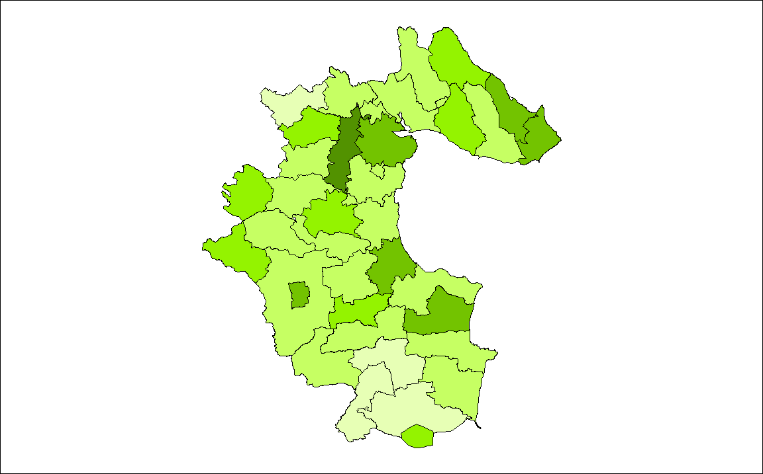
Source: CSO 2002

Table 1: ED’s with a high rate of Older Persons as a % of the Population
Electoral District | % Older persons
Castletown | 20.7
Dundalk Urban | 16.2
Castlebellingham | 16.1
Ardee Urban | 15.1
Dysart | 14.8
Ardee & Environs | 14.7
Carlingford | 14.2
Greenore | 14.2
Drummullagh | 13.9
Jenkinstown | 13.7
County Average | 10.3
Regional Average | 10.1
National Average | 11.1
Source: CSO 2002

Table 2: ED’s with a high rate of Older Males as a % of the Population
Electoral District | % Older persons
Casletown | 18.8
Dysart | 14.6
Castlebellingham | 14.1
Clonkeen | 13.2
Dundalk | 12.9
Jenkinstown | 12.5
Ardee Urban | 12.4
Drummullagh | 12.3
Greenore | 12.3
Ardee & Environs | 12.1
County Average | 8.7
Regional Average | 8.6
National Average | 9.7
Source: CSO 2002

Table 3: ED’s with a high rate of Older Females as a Percentage of the Population
Electoral District | % Older persons
Castletown | 22.7
Dundalk | 19.3
Cstlebellingham | 18.1
Ardee Urban | 17.8
Carlingford | 17.3
Ardee & Environs | 17.2
Dromin | 16.1
Greenore | 16.1
Drummullagh | 15.7
Jenkinstown | 15.0
County Average | 11.8
Regional Average | 11.5
National Average | 12.5
Source: CSO 2002

Older Persons Living Alone in County Louth

In terms of older persons living alone as a percentage of older persons, the ED’s which contain the highest percentage of older persons are outlined in the table below. The majority of these ED’s are in rural Louth. Dundalk Urban ED also has the highest percentage of older persons living alone.

Map 2: ED’s with a high rate of Older Persons Living Alone

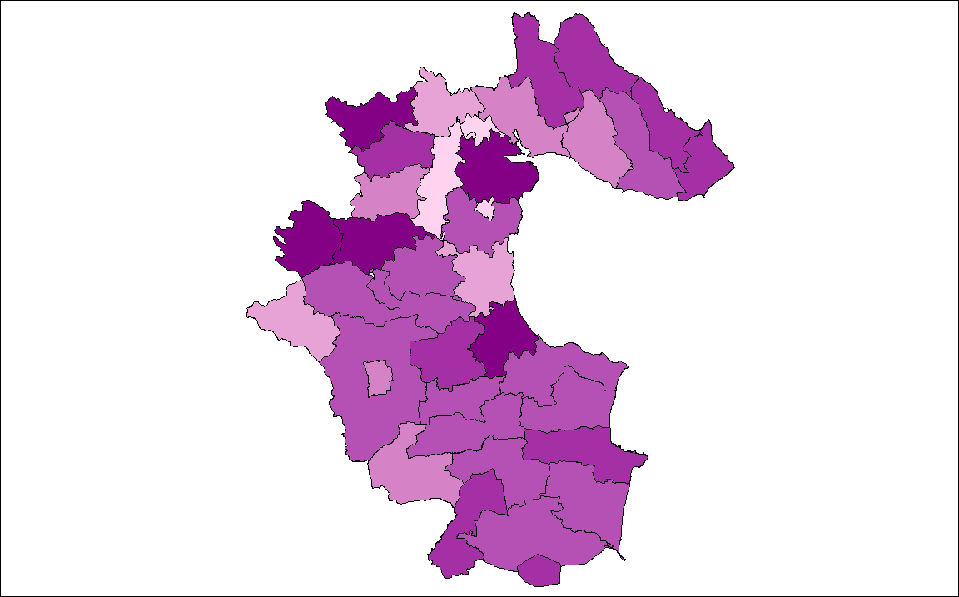
Source: SAPS, 2002

Table 4: DED’s with a high rate of Older Persons Living Alone
Electoral District | % Older persons
Dundalk | 37.4
Creggan Upper | 35.4
Killany | 34.8
Louth | 32.2
Castlebellingham | 31.2
Ravensdale | 29.9
Drummullagh | 29.6
Greenore | 28.4
Carlingford | 28.1
Clogher | 28.1
County Average | 27.5
Regional Average | 25.6
National Average | 26.1
Source: CSO 2002

Persons in Receipt of Old-Age Non-Contributory Pensions
Old Age Non-Contributory Pension is a means-tested payment for people aged 66 or over, who do not qualify for Retirement or Old Age Contributory Pension due to their record of social insurance contributions.

Of the 10,529 older persons (CSO, 2002) in County Louth, there are 1,899 persons (DSFA, May 2004) in receipt of old-age non-contributory pensions. These people are totally reliant on the state as their income, their general welfare, and health services.

Table 5: Persons in Receipt of Old-Age Non-Contributory Pensions
Claim Type | Female | Male | Total
Old age non-contributory pension | 1259 | 640 | 1899
Source: DSFA, May 2004

Graph 1: Gender of Persons in Receipt of Old-Age Non-Contributory Pensions
Old Age Non-Contributory Pension
1259
640
Female
Male

Table 6: Age of Persons in Receipt of Old-Age Non-Contributory Pension
Age | Males | Females | OAP (%)
65-69 | 140 | 237 | 377(19.9%)
70-74 | 161 | 301 | 462(24.3%)
75-79 | 154 | 298 | 452(23.8%)
80+ | 185 | 423 | 608(32.0%)
TOTAL | 640 | 1259 | 1899
Source: DSFA, May 2004

Graph 2: Age of Persons in Receipt of Old-Age Non-Contributory Pension
Source: DSFA, 2002

Table 6 and Graph 2 highlight that the grouping with the most persons in receipt of old-age non-contributory pensions are the 80+ age group (32.0%). These older persons would be less physically and mentally capable in general, than people aged 65-70. They would, therefore be more susceptible to physical isolation. Persons over the age of eighty are more reliant on other people such as their family for everyday needs.

Services for Older Persons in County Louth

The main services provided by the NEHB for older persons include, Community Care Services/Schemes/Supports, Residential Care and Day Care Services and Acute Hospital Services.

Private Nursing Homes for Older Persons
There are eight private nursing homes in County Louth with approximately 314 beds for older people. Private nursing homes also provide residential services on behalf of the NEHB. The rate paid is based on the level of dependency of the patient, and his/her means.

NEHB Hospitals/Units for care of older persons in County Louth
The NEHB provide in-patient residential care for those patients who have become dependent to the extent that they are no longer capable of being maintained in their home environment. This service includes medical, nursing and para-medic services, and aims if at all possible to restore the patient’s independence to the extent that they may return home.
A total of 324 beds are available throughout the county in five public units for care of older persons. There are 638 nursing home/public care unit beds in Louth catering for more than 10,529 (CSO, 2002) people aged 65 years and over.

Day-Care Centres for Older Persons in County Louth
There are eighteen day-care centres for older people. In Ardee Urban there are two day-care centres, with six in Dundalk and five in Drogheda and one in Carlingford, one in Clogherhead, one in Faughart, one in Kilsaran and there is currently one in the process of setting up in Corduff.

Home Help
In August 2004, the average number of home help hours per day that each client receives is 5hrs 9minutes per day, this is provided by 385 home support workers. The number of public health nurses in Louth is thirty three, which includes two who provide a service to schools.

Community Nurses
There are currently six community nurses in the county. (August 2004)

Therapists
The number of occupational therapists in residential units for care of older people in Louth is (2.3) two whole-time and other hours are provided by job-sharing. There are 2.4 physiotherapists caring for older people in the community in Louth and 2.4 based in the residential units. (One in St. Oliver Plunketts and 1.4 in the Cottage Hospital)

Table 7: Centres for Care of Older Persons in County Louth
Name | Location | No. of Beds
St. Joseph’s (Older persons) | Ardee | 44
Boyne View House (Older persons) | Drogheda | 35
St. Mary’s Hospital (Older persons) | Drogheda | 50
Drogheda Cottage Hospital (Older persons) | Drogheda | 48
Dundalk St. Oliver Plunkett (Older persons) | Dundalk | 147
Source: North Eastern Health Board, July 2004

Table 8: Private Nursing Homes in County Louth
Name | Location | No. of beds
Aras Mhuire | Drogheda | 30
Carlingford Nursing Home | Carlingford | 44
Mount Oliver | Dundalk | 28
Conifer House | Dromiskin | 20
Moorehill Lodge | Ardee | 63
Dealgan House | Dundalk | 30
Castle Lodge | Castlebellingham | 39
Blackrock Abbey | Dundalk | 60
Source: North Eastern Health Board, July 2004

One Parent Families
(Source: CSO 2002, DSFA, May 2004)

What is a One-Parent Family?

A One-parent family is generally defined as a family consisting of one parent, who is not cohabitant, is either living alone or with others, and who has dependent children. Such families include single parents, parents who are divorced or separated, and parents who are widows or widowers.

Social Exclusion

One-parent families, especially the single parents themselves, are a high-risk group in terms of social exclusion and disadvantage. One of the main issues for one-parent families would be the issue of childcare. It is essential that single parents have access to affordable and accessible childcare as well as part-time employment.

It is difficult for most single parents, especially those dependent on social welfare benefits as their sole source of income, to have an active social life outside their families. Many single parents may feel they are excluded from normal societal activities.

Employment: Most Effective Means to Overcome Poverty?

Employment (full or part-time) provides the best route out of poverty for single parents and their families. However, because of high unemployment levels, low wage rates, inadequate opportunities for lone parents to obtain further education and training and inadequate childcare provision, this option may not seem particularly feasible to many single parents.

One-Parent Families in County Louth

One-parent family households in County Louth as a percentage of total households in 2002 were 11.7%. Nationally the overall percentage was 10.2%. The majority of ED’s with a high rate of one-parent family households in the county are in the rural areas of the county. It is in these rural areas of the county that it is particularly difficult to access childcare facilities and other facilities in general.

A one-parent family in the rural areas of County Louth is more likely to suffer social exclusion than a one-parent family in the urban centres of the county mainly due to the accessibility of services and the availability of services in the urban centres of the county. Dundalk is the only main urban area with a higher rate of one-parent family households than the county and national average. The ED with the highest rate of one-parent families (Dundalk Rural) has a rate that is 5.1% high the county average and 6.6% higher than the national average.

Map 1: ED’s with significantly high % of one-parent family households in Co. Louth

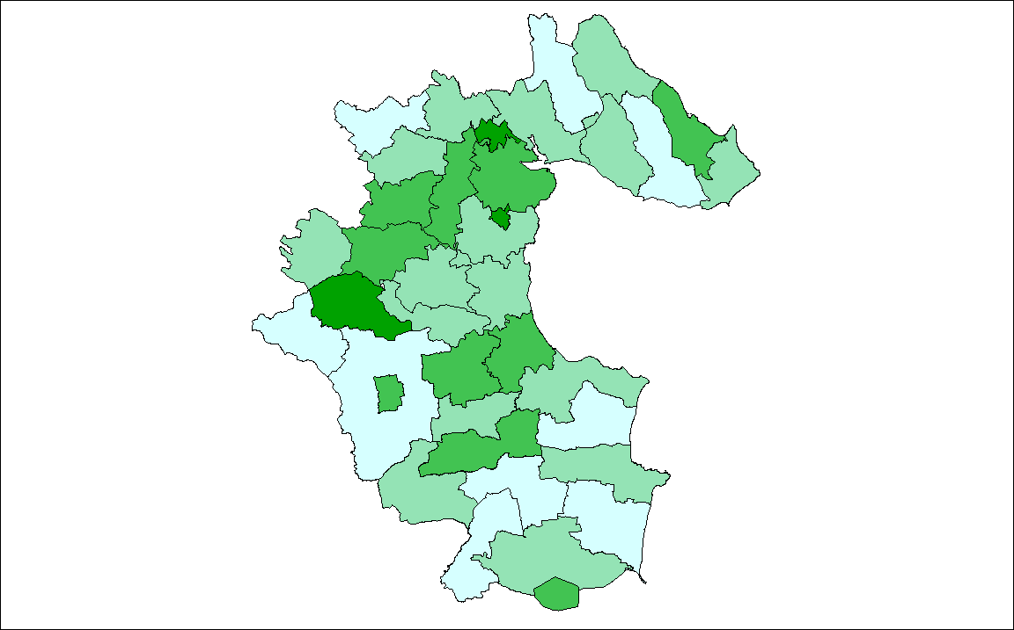
Source: CSO 2002

Table 1: ED’s with significantly high % of one-parent family households in Co. Louth

Electoral Division | % One-Parent Family Households
Dundalk Rural | 16.8
Tallanstown | 15.2
Castlering | 12.9
Castletown | 12.8
Castlebellingham | 12.7
Dunleer | 12.1
Dundalk | 11.8
Ardee + Env. | 11.8
Drogheda | 11.5
Stabannan | 11.5
County Average | 11.7
Regional Average | 10.2
National Average | 10.2
Source: CSO 2002
Map 2: ED’s with significantly high % of father & child households in Co. Louth
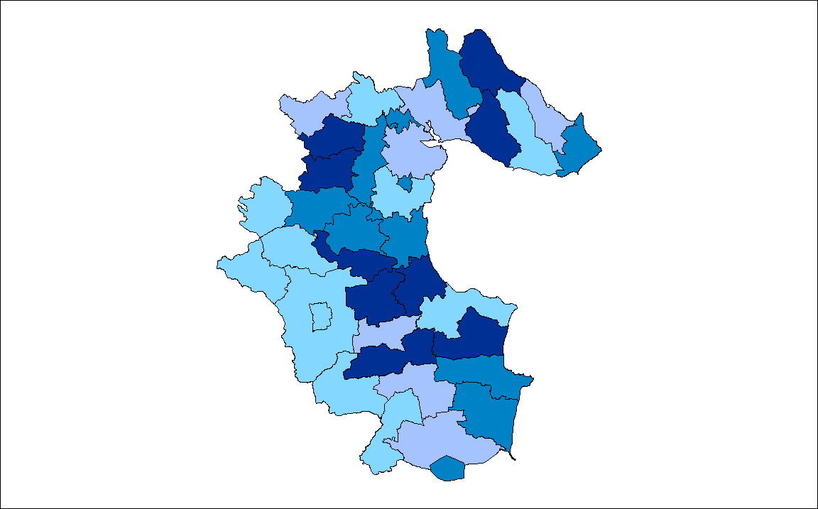
Source: CSO 2002

Table 2: ED’s with significantly high % of father & child households in Co. Louth
DED’s | % Father & Child Family Households
Drummullagh | 3.3
Baronstown | 3.1
Dunleer | 3.0
Stabannan | 2.7
Jenkinstown | 2.7
Castlebellingham | 2.4
Castlering | 2.3
Mansfieldstown | 2.2
Castletown (pt) | 2.1
Ravensdale | 2.1
County Average | 1.6
Regional Average | 1.5
National Average | 1.5
Source: CSO 2002
Map 3: ED’s with significantly high % of mother & child households in Co. Louth
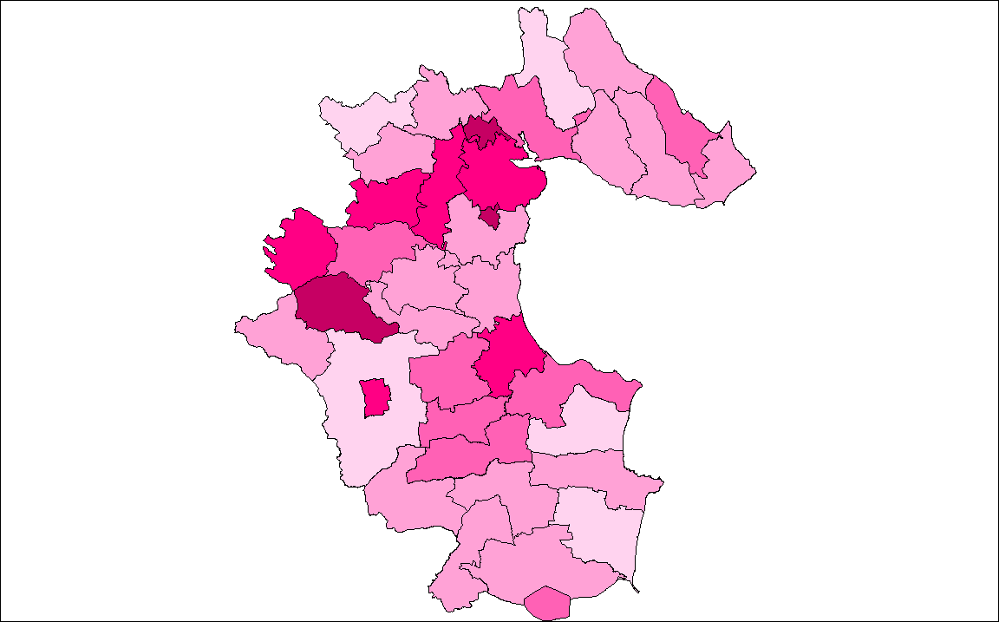
Source: CSO 2002

Table 3: ED’s with significantly high % of mother & child households in Co. Louth
Electoral District | % Mother & Child Family Households
Dundalk Rural | 15.0
Tallanstown | 12.7
Ardee Urban | 11.2
Castletown (pt) | 10.8
Ardee + Env. | 10.6
Castlering | 10.6
Killanny | 10.6
Dundalk | 10.3
Castlebellingham | 10.3
Drogheda | 9.8
County Average | 10.1
Regional Average | 8.8
National Average | 8.7
Source: CSO 2002
One-Parent Family Benefits

One-Parent Family Payment is a means-tested payment, which is made to men or women who are caring for a child or children without the support of a partner. The scheme was introduced on the 2nd January 1997, and replaced lone parent’s allowance, deserted wives benefit & allowance, and unmarried parent’s allowance.

The number of persons in receipt of one-parent family benefits in Co. Louth from the Dept. of Social & Family Affairs (May 2004) is outlined in the following table and graphs. The vast majority of persons in receipt of the allowance are females. This highlights a starch gender imbalance.

Table 4: Persons in receipt of one-parent family benefit in County Louth
Male | Female | Total
2329 | 39 | 2368
Source: DSFA, May 2004

Graph 1: Proportion by Gender of Persons in Receipt of One-Parent Family Benefit in Co. Louth
Source: DSFA, May 2004

Age Profile of Persons on One-Parent Family Benefit in County Louth

In terms of the age profile of persons on one-parent family benefits, nearly three quarters (73.7%) are between 16 and 35 years of age and over half (51.2%) are between 20 and 29 years of age.

27.3% and 23.9% are in the 20-24 and 25-29 years age groups respectively. 16.3% of persons on one-parent family benefit are in the 30-34 years age group. These figures highlight the high number of young single parents. However, only 6.8% of persons on one-parent family benefit allowance are 20 years of age or under.

Table 5: Age of Single Parents in Co. Louth
Age | No. of Single Parents
<20 | 77
20-24 | 729
25-29 | 567
30-34 | 385
35-39 | 309
40-44 | 223
45-49 | 115
50-54 | 32
55-59 | 14
60+ | 0
TOTAL | 2368
Source: DSFA, May 2004

Graph 2: Age of Single Parents in Co. Louth
Source: DSFA, May 2004

Childcare Facilities in County Louth

Geography of Childcare Provision in County Louth
Childcare services in County Louth are geographically clustered together in the main urban areas of Dundalk and Drogheda.

Information provided by Louth County Childcare Committee shows that there are a total of 106 childcare providers in County Louth.

Table 6: Location of Childcare Providers
Location | No. of Childcare Providers
Dundalk | 35
Drogheda | 38
Dunleer | 2
Ardee | 5
Rural Louth | 26
Source: Louth County Childcare Committee July 2004

Graph 3: Location of Childcare Providers
Location of Childcare Providers
33%
35%
2%
5%
25%
Dundalk
Drogheda
Dunleer
Ardee
Rural Louth
Source: Louth County Childcare Committee July 2004

Traveller Community
(Source: Louth County Council 2004, NEHB 2002, CSO 2002)

Travelling Community in Ireland
Travellers are an indigenous minority who, have been part of Irish society for centuries. Travellers long shared history, cultural values, language, customs and traditions making them a self-defined group, and one, which is recognisable and distinct. Their culture and way of life, of which nomadism is an important factor, distinguishes them from the sedentary (settled) population.

Traveller nomadism, the importance of the extended family, the Traveller language and the organisation of the Traveller economy all provide visible or tangible markers of the distinct Traveller culture. The recognition of Traveller’s culture and identity has an importance for Travellers and their status in Irish Society. Cultural difference therefore is a key element to be taken on board in policy design and in procedures by which resources are made available. The important contribution of cultural diversity to the well being of a society should also be acknowledged.

According to the annual count of Traveller Families 2003 there were 5740 Traveller families in Ireland, of which 275 Traveller Families were in County Louth, as specified below.

Table 1: Number of Traveller Families in County Louth
Location | No. of Traveller Families
Dundalk Town Council | 235
Drogheda Borough Council | 32
Louth County Council | 8
Total | 275
This represents 4.3% of the total number of Traveller families in Ireland.

Travellers and Equality
The rights and equalities of the Travelling Community are protected in The Employment Equality Act 1998 and the Equal Status Act 2000.

The Employment Equality Act 1998 outlaws discriminatory practices in relation to and within employment. The Act prohibits direct and indirect discrimination and victimisation in employment on following grounds:
- Gender
- Marital Status
- Family Status
- Sexual Orientation
- Religion
- Age
- Disability
- Race
- Membership of Traveller Community

The Equal Status Act 2000 promotes equality and prohibits types of discrimination, harassment and related behaviour in connection with the provision of services, property and other opportunities to which the public generally or a section of the public has access. The discriminatory grounds are the same as applied in the Employment Equality Act 1998.

“In general, discrimination occurs where a person is treated less favourably than another is, has been, or would be treated on any of the nine discriminatory grounds. Discrimination can be direct, indirect and discrimination by association.

- Direct Discrimination occurs when a person is treated less favourably than another is, has been, or would be treated
- Indirect Discrimination occurs where people are refused a service not explicitly on account of a discriminatory reason but because of a practice or requirement which they find hard to satisfy. If the practice or requirement is found to have the effect of excluding a large amount of the protected group from the services, than the service provider will have indirectly discriminated, if the practice or requirement is not reasonable. Indirect discrimination is more subtle and harder to prove
- Discrimination by Association occurs where a person associated with another person (belonging to the specified groups) is treated less favourably because of that discrimination.”

Traveller Accommodation
The Housing (Traveller Accommodation) Act 1998 provides a legislative framework within which housing authorities address the accommodation needs of Travellers. The Act placed a strong emphasis on consultation of all interests and required all relevant housing authorities to establish Local Traveller Accommodation Consultative Committees, whereby Travellers, Traveller Representatives, Elected Members and Officials, work together to achieve a five-year Traveller Accommodation Programme.

The Minister for the Environment, Heritage and Local Government has directed Local Authorities to prepare, adopt and implement a new Traveller Accommodation Programme for the period 1st January 2005 – 31st December 2008

Traveller Accommodation Programme for County Louth
The Louth Local Authorities, under the provision of the Housing (Traveller Accommodation) Act 1998, established a Local Traveller Accommodation Consultative Committee and prepared a Traveller Accommodation Programme 2000 – 2004 for each of the three housing authorities, Louth County Council, Dundalk Town Council and Drogheda Borough Council. This is the Programme Louth Local Authorities are currently implementing.

The Local Traveller Accommodation Consultative Committee was established on 22 December 1998 and its membership comprises Elected Members, Travellers or Traveller representatives and Local Authority Officials. The committee may:
- Advise in relation to the preparation and implementation of the Traveller Accommodation Programme
- Advise on the management of accommodation for Travellers
- Provide a liaison between Travellers, Elected Members and Officials of the housing authority.

National Traveller Accommodation Consultative Committee
This committee is made up of representatives of local authorities, relevant Government Departments and the Irish Traveller Movement, the National Traveller Women's Forum and Pavée Point. The Traveller Unit in the Department of the Environment and Local Government provide backup to the work of the committee. The committee make input into the memorandum prepared by the Department, for local authorities regarding the implementation of the Housing (Traveller Accommodation) Act. The committee also assist in the production of a code of practice for the operation of the local Traveller Accommodation Consultative Committee and evaluated the adequacy of all the local Traveller Accommodation programmes.

The committee is also looking at the issues of:
1) Monitoring progress on the implementation of the Traveller Accommodation Programmes
2) Developing a co-ordinated response to transient accommodation
3) The adequacy of the provision of Traveller accommodation
4) The design of Caravans for long term living, and the examination of the operation of the caravan Loans Scheme

Traveller Accommodation Programmes 2000-2004
The programmes consist of:
- Assessment of Travellers’ accommodation need
- Categories of Travellers that will be provided with accommodation
- Policy statement in relation to:
  - Provision of accommodation of type, standard and location acceptable to Travellers, within the resources available to the Local Authority.
  - Appropriate consultation with Travellers themselves, traveller representative groups, statutory and voluntary agencies, local traveller accommodation consultative committee, elected members, the public generally and other interested persons or bodies
  - Liaison with the various statutory and voluntary bodies to facilitate the provision of an adequate range of back-up services and facilities for travellers
  - Consideration of the distinctive needs of individual Traveller Families and the cultural background of the Traveller Population generally when providing accommodation.
  - Elimination of unauthorised encampments, as far as possible.

Louth Local Authorities provide a Social Worker service to Travellers. The number of social workers has increased and covers each of the three Louth Local Authorities.

Accommodation is central in the effective delivery of services to Travellers. It is a fact that Travellers’ access to health care, education, employment and social welfare services dramatically improves in situations where their accommodation needs are met. Louth Local Authorities provide the following traveller specific accommodation options:

Serviced halting site
In County Louth there are two serviced halting sites located in the administrative areas of Dundalk Town Council (10 transient bays and 4 permanent bays) and of Drogheda Borough Council (10 bays).
Temporary halting site
In County Louth there is one Temporary Halting site located in the administrative area of Louth County Council.

Special traveller house purchase grant
To encourage home ownership, this special grant is available to Travellers who purchase a new or second hand house for the first time.
Group housing Scheme
Louth Local Authorities have four Group Housing Schemes located in the administrative areas of Dundalk Town Council (17 houses of which 2 are under reconstruction) and Drogheda Borough Council (4 houses).

Caravan Loan and Grant Scheme
The Department of Environment and Local Government has introduced this pilot scheme of repayable loans, together with a grant element, to assist Traveller Families, who live in substandard caravans or in overcrowded conditions, to purchase caravans.
Travellers in County Louth can also avail of all other Local Authority accommodation options and services, details of these can be obtained from the housing department of Louth County Council, Dundalk Town Council and Drogheda Borough Council:

- Standard Local Authority housing
- Tenant Purchase Scheme
- Affordable Housing Scheme
- Shared ownership Scheme
- Disabled Persons Reconstruction Grant Scheme
- Local Authority Loans for House Purchase
- Local Authority Loans for House Improvements
- Local Authority Improvements Works in Lieu
- Mortgage Allowance Scheme

Traveller Statistics
According to the Annual Count of Travellers in November 2003, Traveller families in County Louth have availed of the different accommodation options as shown below.

Table 2: Types of Traveller Accommodation
Type of Accommodation | Number | Of | Families
 | Louth County Council | Dundalk Town Council | Drogheda Borough Council | Total
Private Ownership | 2 | 54 | 2 | 58
Standard Local Authority Housing | 0 | 117 | 8 | 125
Group Housing | 0 | 13 | 3 | 16
Serviced Halting Site | 0 | 2 | 3 | 5
Basic Service Bays | 0 | 0 | 0 | 0
Voluntary Housing Schemes | 0 | 6 | 1 | 7
Private Rented Accommodation | 2 | 31 | 8 | 41
Sharing with Tenants/Owners | 0 | 8 | 4 | 12
Roadside | 4 | 0 | 0 | 4
Unauthorised Encampments | 0 | 4 | 3 | 7
Total | 8 | 223 | 32 | 275
Source: Louth County Council 2003

Age Structure of the Traveller Community
The Traveller Community identified during the course of the Census of Population in 2002 had a markedly different age structure from that of the population in general. 42.2% of the Travellers identified were aged less than 15 years compared with less than one quarter of the total population of the country (21.1%).

Older Travellers (65 years or more) accounted for 3.3% of the Traveller population while the corresponding proportion for the population in general was 11.1%. The high birth rate prevalent in the Traveller community is reflected in the younger age group. There is a sharp contrast between the age structure of the Traveller Community and the overall population.

Young Travellers make up the majority of the Traveller community in Ireland. In 2002, 62.7% of Travellers were under the age of 25 and 42.2% are under 15 years of age.

Age Structure of the Travelling Community in County Louth
The socio-demographic profile of the travellers in County Louth reflects a mainly young population. (Figures below are based on the findings of the North Eastern Health Board Annual Report 2002)

Table 3: Age Structure of Traveller Families
Age | % of Travelling Community
>18 | 71%
18-64 | 28%
≥65 | 1%

Graph 1: % Age Structure of Travelling Community
Source: NEHB Annual Report 2002

It is therefore of significant importance that the age structure of the Travelling Community is taken into consideration when planning and delivering services such as accommodation, education, health etc.

Travellers and Education
The Department of Education and Science provide additional resources to encourage Traveller participation in education. These include:
- Resource teachers in primary and secondary schools,
- Visiting teachers
- Traveller pre-schools
- Training Centres
- Transport to school (in specific circumstances)

In addition there are a range of employment and training schemes available through the Departments of Enterprise and Employment, Education and Social Welfare, that individuals and groups can access.

At local level various initiatives have resulted in improved school attendance of Traveller children in County Louth. It is important to stress that Travellers have the same obligations and rights as the settled population i.e. their legal obligation to attend school and their right of access to all levels of the educational system in Ireland.

Traveller Specific Services in County Louth

Tara Workshop
This is a twenty four place training centre for Traveller women in the County Louth area. It was established jointly by the Dundalk Travellers Committee and Dundalk Town Council. It is funded by Co. Louth V.E.C. and offers Traveller women aged 16+ a return to education and obtain N.V.Q in a variety of subjects. The programme is over a three-year period and a Training allowance and childcare allowance is paid.

Dundalk Travellers Community Employment Scheme
This project was established by Dundalk Travellers Committee and Dundalk Town Council in 1993. It provides employment opportunities for seventeen Travellers (all of whom are long-term unemployed). They work in various projects e.g. pre-school, coffee shop, sports complex, Tara workshop, and Homework club. Through the scheme a number of Travellers have obtained recognised childcare qualifications.

Right Start Dundalk Travellers Pre-school
This project was initiated by Dundalk Travellers Committee, Dundalk Town Council and St Joseph’s National School, Muirhevnamór in September 1994. It caters for ten Traveller children from the Dundalk area. It employs a qualified teacher and three classroom assistants all of whom are Travellers with recognised childcare qualifications.

Home Work Club
This was established by Dundalk Town Council and Dundalk Travellers Committee. It provides a homework service for Traveller children. It is run by Travellers through Dundalk Travellers Community Employment Scheme. It is funded by Dundalk Town Council and Dundalk Travellers Committee and FÁS.

Dundalk Travellers Committee
This committee was formed in 1967 in response to the recommendations of the Commission Report on Itinerancy (1963-1966). It is a sub-committee of the Society of St. Vincent de Paul. The group is based in Ozanan House, Jocelyn Street, Dundalk. Dundalk Town Council has worked closely with the committee in identifying and maintaining projects in consultation with the Traveller Community.
The aims and objectives of the Dundalk Traveller Committee are:
- To facilitate a self-help ethos among Travellers.
- To facilitate and support Travellers to live the life of their choice to its fullest potential.
- To promote and implement the rights and responsibilities of the Travelling Community.

Drogheda Traveller Women Group
D.A.W.N organises and supports Traveller woman groups in Drogheda.

Louth Primary Health Care Project
This project was established by Dundalk Town Council and Dundalk Travellers Committee in 1998. Ten Traveller women were trained as Primary Health Care workers for twelve months under the Dundalk Traveller Community Employment Scheme. The project is now run by the North Eastern Health Board who employs the women on a part time basis. They provide health information to the Traveller Community in the County Louth community care area.

Summer Project
This project was initiated by Dundalk Traveller Committee and Dundalk Town Council. It provides sports based activities for Traveller children in the Dundalk area. It is organised and run by Travellers in Dundalk Town Council Sports and Leisure Complex, Muirhevnamor. It is funded by Dundalk Travellers Committee, Louth County Council and Dundalk Town Council.

Contacts in Louth Local Authorities

Louth County Council Dundalk Town Council
Housing Officer / Social Worker, Housing Officer / Social Worker,
Millennium Centre, Town Hall,
St. Alphonsus Road, Crowe Street,
Dundalk, Dundalk,
Co. Louth. Co. Louth.
Telephone: 042 – 9335457 Telephone: 042 - 9392988

Drogheda Borough Council
Housing Officer / Social Worker,
Fair Street,
Drogheda,
Co. Louth.
Telephone: 041- 9833511

Ex-prisoners and Displaced Persons
(Source: Failte Abhaile)

Introduction
In 1998 ‘The Good Friday Agreement’ was endorsed by the vast majority of the people in Ireland. Subsequently, large numbers of prisoners were released back into the community. Many of these ex-prisoners joined the existing number of displaced families living in Co. Louth, mostly in Dundalk and the north of the county.
The issue of ex-prisoners is controversial and the effect of the thirty years of conflict is still ongoing for many ex-prisoners and their families. It is important to ensure the social inclusion of this group. This is one of the many challenges emanating from the peace process that needs to be faced.
Number of Ex-prisoners and Displaced Families in Co. Louth
It is estimated by Fáilte Abhaile, a group for Republican Ex-prisoners in Dundalk, that there are 150 ex-prisoners and their families in the Dundalk area, plus 250 displaced families, which means there are around 2,000 people who can and do avail of the group’s services.

Main Problems facing Ex-prisoners and Displaced Families
- The majority of ex-prisoners are from disadvantaged backgrounds
- Ex-prisoners (political) are treated as criminals with criminal records. This means they are restricted in what they can do in employment and other areas of life e.g. they cannot drive taxis, adopt children, and travel is restricted, etc.
- 40% of ex-prisoners are unemployed with many having no qualifications or skills as access to training and education was denied to prisoners before the ‘blanket protest’. They also face discrimination in employment because of their past
- Children of ex-prisoners suffer prejudice because of their parents’ past. They also experience the lack of identity because the family have had to move

Support Groups for Ex-prisoners and Displaced Families
The main support group for ex-prisoners and displaced families in Co. Louth is Fáilte Abhaile, which is based on Bridge Street, Dundalk. The mission statement of the group is:

‘To develop an inclusive, sustainable local community infrastructure to support republican prisoners, displaced people and their families, and enable them to fulfil their potential and participate in the regeneration of the community, increasing their education and employability levels and status’.

This support groups offers a number of services including the following:
- Drop in centre
- Training and education courses
- Counselling and emotional support
- Community development
- Wide range of courses such as Computers, Basic English and Maths, Book Keeping

Fáilte Abhaile is also involved in the community with members actively involved in over 50-60 local groups in Dundalk.

